Local solution setup

Github : https://github.com/gopisivanappanvasanthi/Trn/tree/develop

1. Go to Trn.Project.TrnSite.Serialization.base.config configuration present under Trnsite project and Change unicorn source folder path to your local solution path

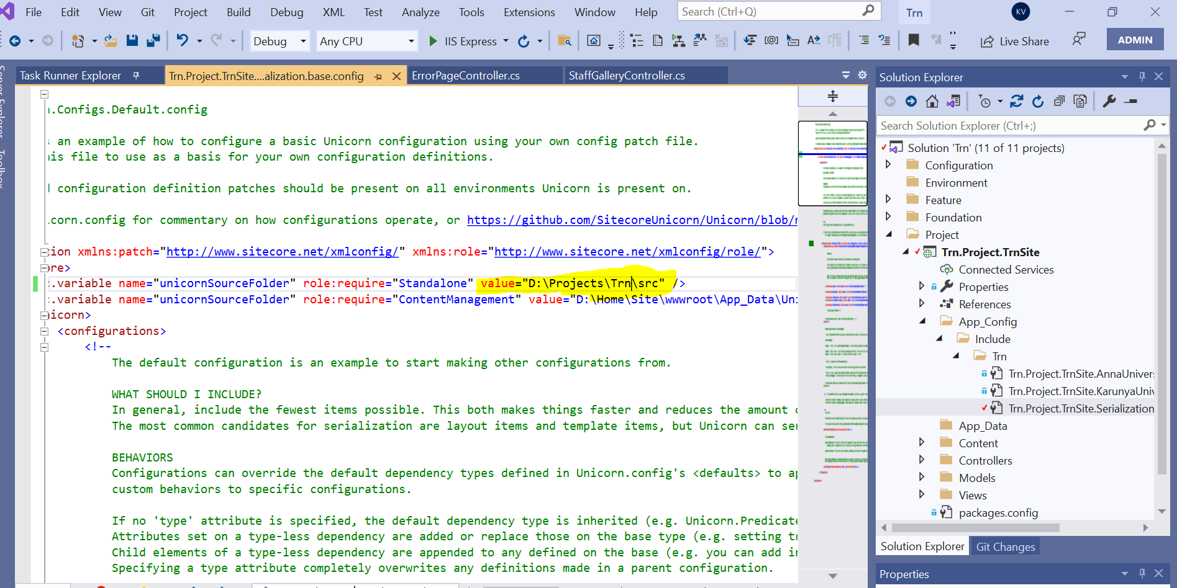

2. Go to gulp-config.js file and change instance root path to your local site core instance path.

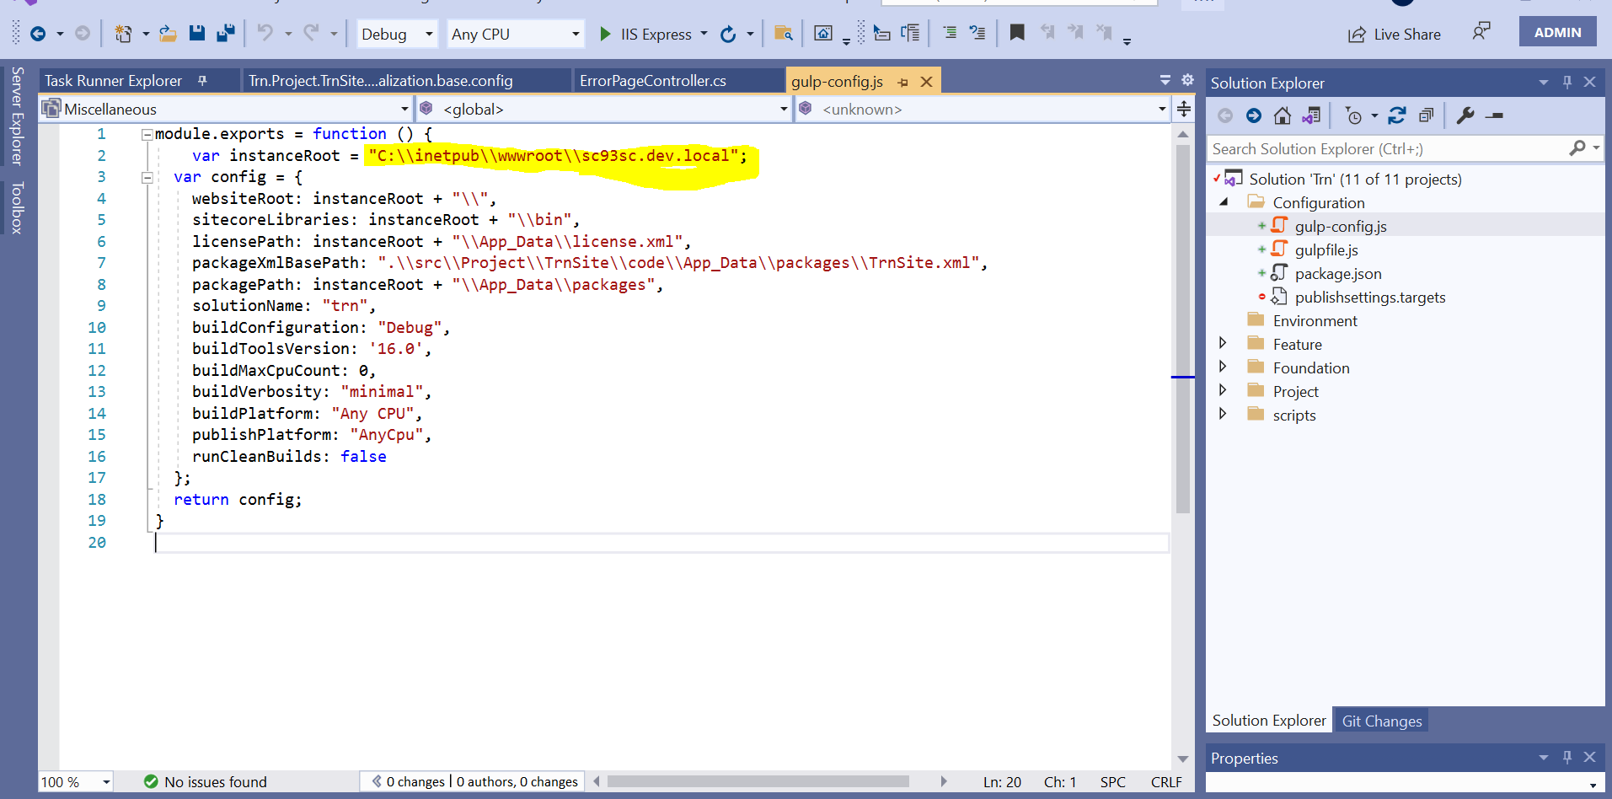
3. Open publishsettings.targets file and change publish url to your local site-core instance url.

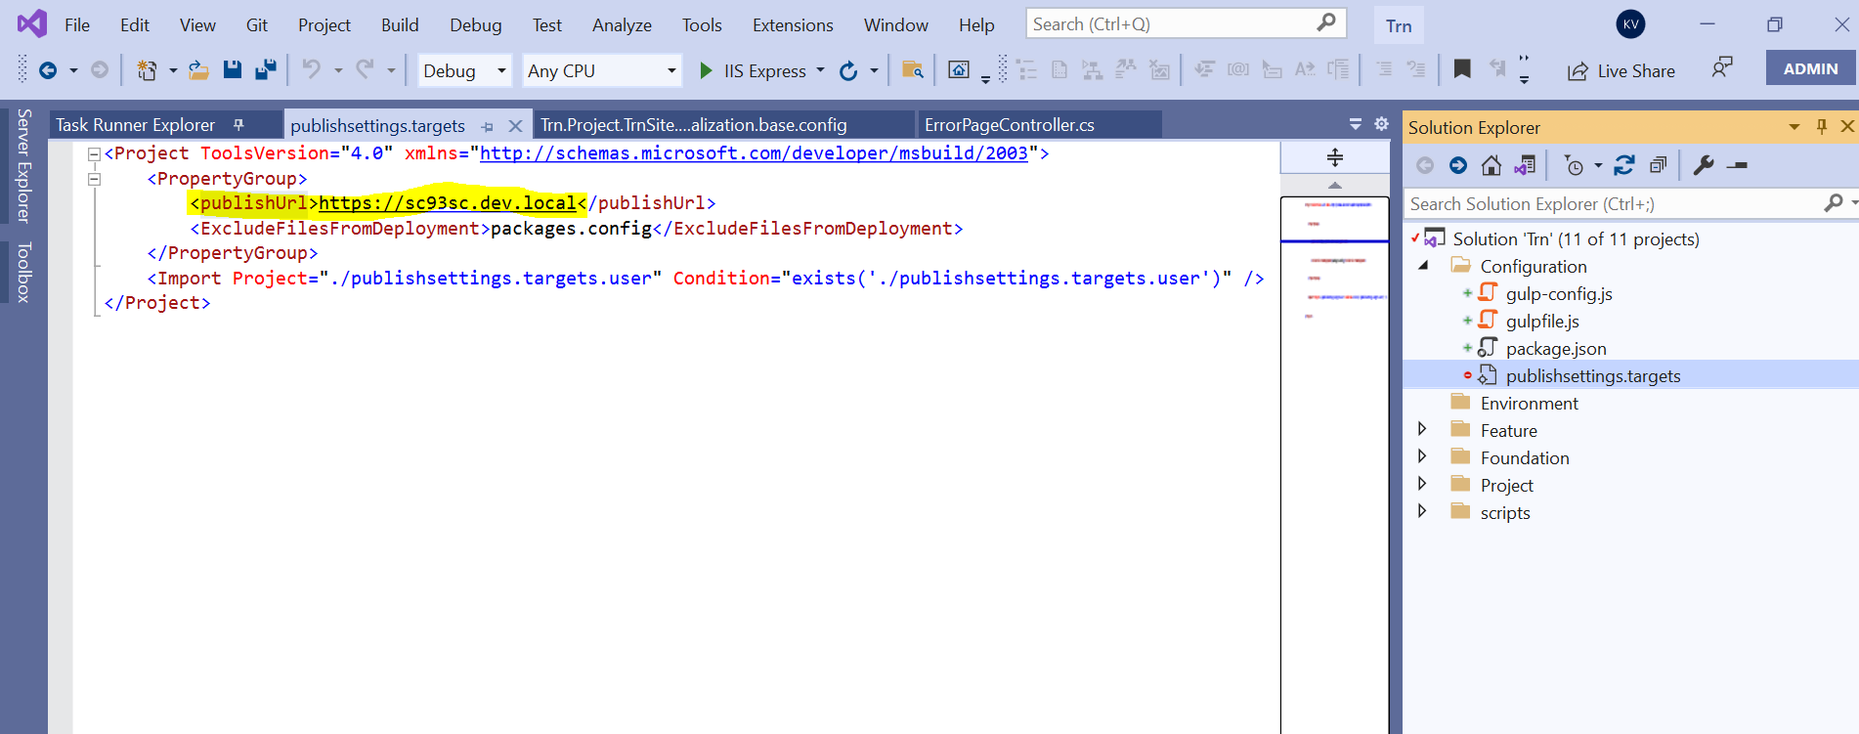
Once configurations changes is done , Open your solution folder in command prompt and execute following commands.

1. npm install
2. npm install -g gulp

After executing above commands , open Task runner(view=>other windows=>task runner) in visual studio and we can see list of gulp tasks.

